ML Signal Processing Pipeline
1. Purpose of this document
This document defines the shared signal-processing and feature-extraction pipeline for the DSP Finger-Tapping project. It is intended to provide all group members with a clear, consistent reference for how raw finger-tapping amplitude–time signals should be transformed into numerical features for machine learning.
The focus is on practical execution, capturing key decisions, assumptions, and constraints agreed upon from the project charter, client meeting, and group research. It outlines what inputs are expected, how signals should be processed, and what outputs should be produced, ensuring consistency across individual implementations.
This document is not an assessed academic report and does not cover model selection or evaluation in detail. Its purpose is to support coordination, reduce ambiguity, and ensure that signal-processing work across the group follows a common, clinically informed approach.

2. Pipeline Flowchart
2.1 Flowchart
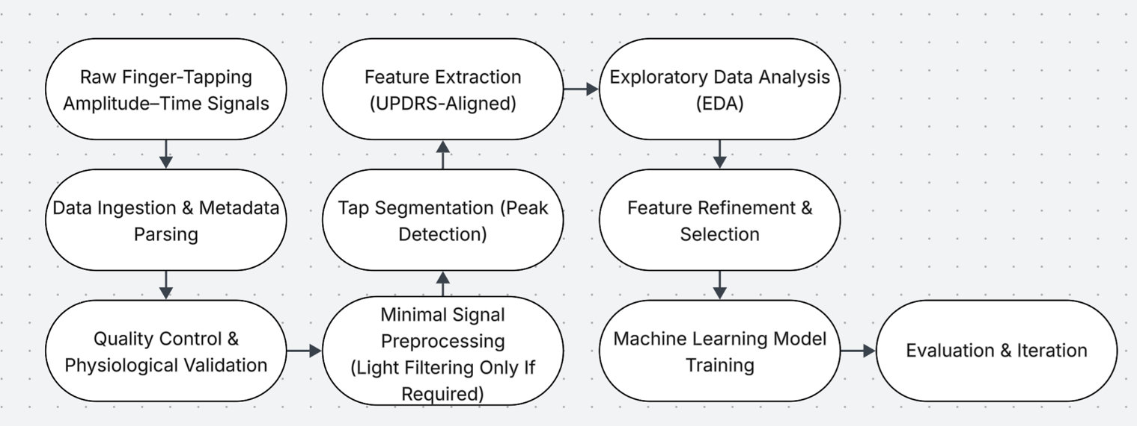
2.2 Step-by-Step Execution Guide
Step 1: Raw amplitude–time signals
Goal: Start from the project’s primary representation: amplitude vs time per trial, per hand.
Inputs: Raw signal files (normalised amplitude), severity labels.
Actions (checklist):
- Confirm each signal is amplitude–time (not velocity) as per client guidance.
- Confirm each sample is tagged with hand (L/R) and UPDRS label.
Outputs: A list/index of all samples available (IDs + metadata).

Step 2: Data ingestion & metadata parsing
Goal: Load signals consistently and attach correct metadata.
Inputs: Signal files + labels file (or embedded labels).
Actions (checklist):
- Load each signal as two arrays: t[] (or index) and amp[].
- Create a unique signal_id for every sample.
- Treat left and right hands as separate samples (PD asymmetry).
Outputs: A master table (CSV/dataframe) with: signal_id, participant_id, hand, label, path.
Note: Time may be implicit (index-based) if signals are uniformly sampled.

Step 3: Quality control & physiological checks
Goal: Detect corrupted/invalid signals before processing.
Inputs: Loaded amp[] signals.
Actions (checklist):
- Flag missing values / empty signals.
- Flag near-flat signals (very low variance).
- Flag unrealistic behaviour (e.g., extreme oscillation that suggests tracking artefacts).
- Record QC flags rather than deleting immediately (so you can audit later).
Outputs: qc_report.csv with pass/fail + reason codes.
(This aligns with the charter’s risks: data limitations + generalisation issues.)
Note: Signals failing QC should be flagged and excluded from downstream feature extraction unless explicitly reviewed.

Step 4: Minimal preprocessing (light filtering only if required)
Goal: Remove obvious noise while preserving clinically meaningful variation.
Inputs: Raw amp[] (passed QC).
Actions (checklist):
- Default to no filtering unless peak detection fails or signal is clearly chaotic.
- If filtering is needed, use light smoothing (client recommended low-order Savitzky–Golay; avoid aggressive smoothing).
- Store both: amp_raw[] and amp_proc[] so decisions are reversible.
- Log filter parameters in a config file.
Outputs: Processed signals + preprocess_config.yml.
Note: If peak detection produces implausibly many peaks (e.g. rapid oscillations) or misses clear taps on visual inspection, apply light smoothing and retry.

Step 5: Tap segmentation (peak detection)
Goal: Identify taps as peaks to enable timing + amplitude features.
Inputs: amp_proc[] (and/or raw as fallback).
Actions (checklist):
- Run peak detection with constraints:
  - minimum distance between peaks (prevents tremor/noise micro-peaks)
  - prominence/height threshold (prevents false peaks)
- Convert peak indices → peak amplitudes (client flagged common mistake: using indices as values).
- Save diagnostic plots for a small sample across classes (for debugging + appendix).
Outputs: For each signal: peaks_idx[], peaks_amp[], n_peaks.
Note: Peak detection should produce one peak per visible tap for most signals; signals with extreme over- or under-detection should be flagged for review.

Step 6: Feature extraction (UPDRS-aligned)
Goal: Convert tap structure into clinically meaningful numerical descriptors.
Inputs: Peaks + timing arrays.
Actions (checklist):
- Extract features mapped to UPDRS item 3.4 constructs:
  - Amplitude (mean/variability)
  - Rhythm (ITI mean/CV)
  - Hesitations (long pauses, max ITI)
  - Decrement (first peak vs last-3 mean; client explicitly suggested this).
- Ensure ≥10 clinically relevant features (charter requirement).
Outputs: features.csv (one row per signal_id).

Step 7: Exploratory data analysis (EDA)
Goal: Validate that features behave sensibly before modelling.
Inputs: features.csv + labels.
Actions (checklist):
- Plot distributions per severity group (spot obvious failures).
- Check correlations to identify redundant features.
- Identify outliers and trace back to segmentation/QC logs.
- Compare raw vs filtered features on a subset to ensure filtering didn’t erase meaningful variance (client concern).
Outputs: eda_summary.pdf (plots) + eda_notes.md.
Note: EDA is considered sufficient once feature distributions are plausible, extreme outliers are understood, and no obvious feature extraction failures remain.

Step 8: Feature refinement & selection
Goal: Keep features that help prediction and remain interpretable.
Inputs: EDA insights + candidate feature pool.
Actions (checklist):
- Remove obvious redundancy (highly correlated features).
- Use simple importance checks (permutation importance / tree-based importance) to rank features.
- Keep a “core set” + optional add-ons so the model team can test different subsets.
Outputs: features_selected.csv + feature_selection_notes.md.

Step 9: ML model training
Goal: Train classifiers on refined features.
Inputs: features_selected.csv.
Actions (checklist):
- Follow the shared methodology: stratified splits + cross-validation.
- Ensure hand-based samples are handled consistently (no leakage by patient if relevant).
Outputs: trained model artifacts + experiment logs.

Step 10: Evaluation & iteration
Goal: Use errors to improve upstream processing/features.
Inputs: model results + error cases.
Actions (checklist):
- Inspect misclassified samples and trace back to segmentation/QC.
- Adjust peak parameters or feature definitions if failures are systematic.
- Document changes so they can be reflected on later (Element 2 reflection).
Outputs: updated config + changelog.

3. Pipeline Stages
3. Feature Groups Summary
This section summarises the feature groups to be extracted from the finger-tapping amplitude–time signals. The features are organised according to the clinical constructs defined in MDS-UPDRS item 3.4 and refined based on signal-processing literature and guidance from the client.
The aim is to start with a clinically meaningful but flexible feature pool, which can later be refined through exploratory data analysis and model-based evaluation.
3.1 Feature Group Overview
Feature Group | Clinical Meaning (UPDRS 3.4) | Example Features | Why This Group Is Required
Amplitude | Reduced movement size | Mean peak amplitude, amplitude variability | Captures overall tap strength; reduced amplitude is a core bradykinesia indicator
Amplitude Decrement | Progressive reduction during task | First peak vs last-taps average, amplitude slope | Explicit UPDRS criterion; client emphasised importance of decrement
Rhythm / Timing | Slowness and irregular rhythm | Mean inter-tap interval (ITI), ITI CV, taps per second | Differentiates steady vs impaired tapping patterns
Hesitations / Halts | Interruptions in movement | Long pause count, maximum ITI | Captures freezing-like behaviour and task interruptions
Trend / Fatigue | Performance deterioration over time | ITI trend, amplitude trend | Reflects worsening performance across the task
Validity / Artefact Indicators | Signal reliability | Peak success rate, implausible frequency ratio | Prevents artefact-driven features from misleading the model

3.2 Feature Group Description
A. Amplitude Features
Describe the magnitude and consistency of finger taps. These features quantify how strongly the finger moves during each tap and how consistent this movement is across the trial.
Purpose:
Detect reduced movement size and variability associated with bradykinesia.
B. Amplitude Decrement Features
Measure how tap amplitude changes over time, particularly whether amplitude decreases as the task progresses.
Purpose:
Directly maps to UPDRS item 3.4’s amplitude decrement criterion.
The client specifically recommended comparing early taps to later taps to quantify this effect.
C. Rhythm and Timing Features
Capture the temporal structure of tapping, including speed and regularity.
Purpose:
Differentiate between consistent rhythmic tapping and slowed, irregular tapping patterns typical of Parkinson’s impairment.
D. Hesitation and Halt Features
Quantify interruptions in tapping behaviour, such as unusually long pauses between taps.
Purpose:
Identify hesitations and halts, which are clinically relevant indicators of impaired motor control and are often difficult to score reliably through visual assessment alone.
E. Trend / Fatigue Features
Model gradual changes in tapping behaviour across the duration of the task.
Purpose:
Capture progressive slowness or weakening that may not be evident from summary statistics alone.
F. Validity and Artefact Features
Identify whether extracted features are based on reliable signals or influenced by tracking noise and artefacts.
Purpose:
Support quality assurance and prevent physiologically implausible behaviour from biasing the model.

3.3 Feature Pool Strategy
Rather than fixing a strict number of features at this stage, the pipeline adopts an initial candidate feature pool spanning all groups above. This ensures:
- Coverage of all clinically relevant UPDRS constructs
- Sufficient diversity for exploratory analysis
- Flexibility to refine features based on EDA and model feedback
The final feature subset will be determined empirically during model development, allowing the data to guide feature selection while maintaining clinical interpretability.

4. Key Decisions and Constraints from Client Consultation
The following design decisions were derived directly from discussions with the client (Ramzi) and must be respected during implementation of the signal-processing and feature-extraction pipeline:
- Amplitude–time signals are the primary representation.
Derived signals (e.g., velocity) should not be used as the main input, as they may introduce distortion and obscure clinically meaningful behaviour.
- Minimal filtering is preferred.
Aggressive smoothing can artificially suppress variability related to bradykinesia. Light filtering should be applied only when necessary to support reliable peak detection.
- Physiological plausibility must be enforced.
Extremely high-frequency oscillations (e.g., >10 Hz) are unlikely to reflect true Parkinsonian movement and should be treated as artefacts.
- Left and right hands must be treated as independent samples.
Parkinson’s disease often presents asymmetrically; combining hands risks masking clinically relevant differences.
- Feature design should remain exploratory but interpretable.
The client emphasised that AI should be allowed to explore meaningful patterns, provided the resulting features can still be related back to UPDRS criteria.
These constraints guide all downstream signal-processing, feature-engineering, and modelling decisions and provide a clinical reference point for later evaluation and reflection.
5. Notes for AI Assistance
- QC-failed signals: flagged and excluded from feature extraction unless manually reviewed
- Filtering: applied only if peak detection fails on raw signals; use light smoothing and retry
- Long pause definition: inter-tap interval greater than 1.5× the median ITI of the signal
- Segmentation success criterion: approximately one detected peak per visible tap
- EDA completion criterion: no extreme outliers caused by extraction errors; feature distributions are plausible across classes
- Output format: each pipeline stage produces a CSV or data frame with one row per signal (per hand)

